THE DAILY CHASE
“SEEKING THE LORD’S FACE LIKE NEVER BEFORE”
VOLUME 4

THE THINGS NO ONE WANTS TO TALK ABOUT

It seems like no one cares. There is so much going on and these things are affecting us deep within. The things that you’re going through that are heart penetrating are things that cannot be shared with a confidant or close friend. They cannot understand. You can’t explain your whole life to them and leave yourself that vulnerable. How can you talk about the emptiness? Who do you talk to about domestic and sexual abuse that you endured as a young child without going to some uninvolved psychologist? What can you do to overcome the anger that you feel, not just toward a particular person, but toward yourself? Why does it seem like those who don’t care and who don’t love seem to get so far? Does everything have to be so shallow while people do all sorts of things to avoid all of the real problems in their lives? You’ve heard this saying before and I will say it again because faith comes by hearing and hearing by the word of the Lord. Jesus Christ really does love you. He really did come and lay down his life and picked it up again along with the keys of death and the grave so that he could have a personal relationship with you. He wants to know you and He wants you to know Him. He doesn’t just want you to know about him or collect a whole lot of knowledge. He wants you to be in unity with him in the faith by His Holy Spirit, and feel the comfort of his love. He said come unto me, all ye that labor and are heavy laden, and I will give you rest. Take my yoke upon you, and learn of me; for I am meek and lowly in heart: and
I COR 12:25-27 THAT THERE SHOULD BE NO SCHISM IN THE BODY; BUT THAT THE MEMBERS SHOULD HAVE THE SAME CARE ONE FOR ANOTHER.
AND WHETHER ONE MEMBER SUFFERS, ALL THE MEMBERS SUFER WITH IT; OR ONE MEMBER BE HONORED, ALL THE MEMBERS REJOICE WITH IT. NOW WE ARE THE BODY OF CHRIST, AND MEMBERS IN PARTICULAR.
Ye shall find rest unto your souls. For my yoke is easy and my burden is light (Matt 11:28-30). When you’re going through tests and trials or even overcoming loss and grief, you must remember that there is always some kind of force behind the trouble. Jesus Christ allows things to show forth his manifest glory in a situation for those willing to believe on him. He came that we may have life and have it more abundantly. Everything that one could possibly go through in this life has already been nailed to the cross for us to overcome. These trials are faith builders and are not for us to give up and be overtaken by the cares of the world. However, whatsoever is born of God overcometh the world: and this is the victory that overcometh the world, even our faith (I John5:4). So, when you’re not sure how you’re going to make it through, you pray a simple prayer to the Lord Jesus Christ so that he can intervene on your behalf. Ask for strength and wisdom to trust and endure. Praise the Lord because praise is a garment that He has given us for the spirits of heaviness. Seek Him for His Holy Spirit because His Spirit is His manifest presence upon you to lead you and guide you in the paths of all truths and righteousness. He is there. He cares for you. Trust and believe and He will be everything in your life that you need Him to be.
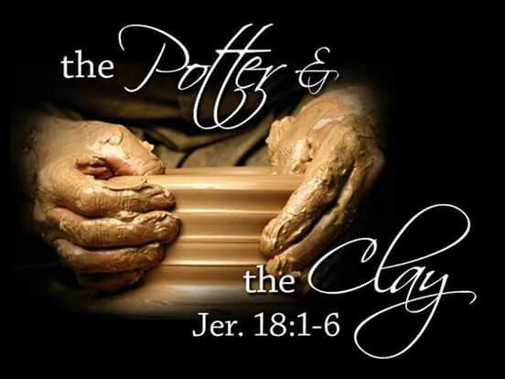
THE POTTER’S SPECIALTY
The Lord Jesus Christ is the Master Potter. His children are the clay. His specialty is brokenness. Ps51:17 The sacrifices of God are a broken spirit: A broken and contrite heart, O God, thou wilt not despise. The potter is the one with the vision of how the vessel should be shaped and molded. He specializes in healing brokenness and mending relationships. When the potter puts the clay on the working wheel, He doesn’t focus on the outside but takes his hands and starts to mold the clay from the inside out. He mends broken hearts. He sets captives free. He uproots everything that’s not supposed to be there and once he starts to makeover that vessel, He fills it with an abundance of spiritual pleasures that will bring forth the manifestation of His glory. He fills the vessel with His Holy Spirit. He pours His spiritual gifts and talents. Then puts us in position to walk in the fruits of the Spirit and bring forth fruits of righteousness. Heb 4:15-16 For we have not an High Priest which cannot be touched with the feeling of our infirmities; but was in all points tempted like as we are, yet without sin. Let us therefore come boldly to the throne of grace, that we may obtain mercy, and find grace to help in the time of need. The Lord Jesus Christ had been touched with every one of our weaknesses. He understands every weak place and vulnerability. Jesus Christ knows our very being and the plan he has for our lives. He formed us. He created us even before the foundations of the world. So, understand that we have been created to do the Lord’s will and His purpose. We have not been created with man’s hands but by His Spirit has He shaped us for His glory. Think it not strange the things that have occurred in your life. The things that have taken place were designed for us to walk in our Most Holy faith and trust in the Lord with all our heart. His ways are higher than our ways and His thoughts are higher than our thoughts. His plans are to prosper us and bring us to our expected end. The requirement is surrender! Jesus Christ is a gentleman. He doesn’t put us on the potter’s wheel by force. He wants your willingness to come unto Him and trust that he has your best interest at heart. Present yourself a living sacrifice, Holy, acceptable unto God, which is your reasonable service.
TEACH ME TO PRAY
You’ve probably been partaker or prayer while in the midst of a sports team huddle just before the championship game, or while gathering over an abundant platter for Thanksgiving Dinner. Prayer is more than just asking the Lord for something that you want. Heb 11:6 But without faith it is impossible to please Him. For he that cometh to God must believe that He is, and that He is a rewarder of them that diligently seek Him. Prayer is an acknowledgement that God is and that He is the first, the Last, the beginning, and the end. Prayer is an acknowledgement of a reverent fear of the Lord and that He is the author and the finisher of our faith. It is a form of communication and an act of petitioning the Father God through His son Jesus Christ to intervene on your behalf regarding situations and circumstances. To come boldly to the throne of grace requires total surrender and repentance to the Most High. The repentance is the recognition that you have sinned and transgressed but have a desire to put away the sin and walk in the way of righteousness. You acknowledge the need for a savior and that the blood that Jesus Christ has shed on the cross will cleanse you. Then you’re in position to ask the Lord to reveal his will and purpose for your life. He is your redeemer. Therefore, you are not in control of your own destiny. He has the plan of action for your life. Some people think prayer has to be long and in some kind of form of fashion. The fact is that the Lord Jesus loves you. He wants you to communicate in that love with sincerity and truth. The he wants you to be in position to wait on the answer and trust that the answer He give you is just, even if it’s not what you want to hear. He has commanded that we watch as well as pray. Sometimes when we see what we see and hear what we hear, all we can do is call on the name of Jesus Christ, the true and living God; that is our prayer. No matter the circumstance, no matter the situation Jesus Christ is just a prayer away. He is the answer; no matter what you’re going through. If you’re willing to let him reign in your life, He will be there. You do not have to settle for your current situation. He will go through with you if you allow him to.
Matthew 7:7-8
Ask, and it shall be given you; seek, and ye shall find; knock, and it shall be opened unto you: For everyone that asketh receiveth; and He that seeketh findeth; and and to him that knocketh it shall be opened.
WARFARE WHISPER
Many people were on life support and those who were sent to help them did not give them the truth. They did not go forth in complete obedience to the word of the Lord. Partial obedience is still disobedience. Many who were chosen have been slaughtered. Spiritual warfare is real. The Lord has given us weapons of warfare and has commanded us to put on the whole armor. We must keep fighting the good fight of faith. Don’t take down. Much of what the Lord has sent us to do is not popular. It will seem as if you are a cast away sometimes, but remember Jesus paid the ransom. We cannot take our commitment lightly. He paid for all of you not just a piece. The Lord has designed all of us for a testimony, but there can only be a testimony if you overcome. Sometimes the Lord is allowing us to be tested for elevation purposes but then folks run to man to deliver you out of a situation rather than give the glory completely to Christ. Christ wants to be your only source especially in times of trouble. Why run to friends and family or whomever for a temporary fix when Christ is everlasting? Worry is for the unbeliever. If you can see the end result then its no longer faith. The just shall live by faith, not by sight. You must overcome…there is no other option. Stand by the word, having done all…stand. The overcomers shall see God. Revelation 3:19-22 As many as I Love, I rebuke and chasten: be zealous therefore, and repent. Behold, I stand at the door, and knock: if any man hear my voice, and open the door, I will come in to him, and will sup with him, and he with me.
To him that overcometh will I grant to sit with me in my throne, even as I also overcame, and am set down with my Father in his throne.
He that hath an ear, let him hear what the Spirit saith unto the churches.
These things have I spoken unto you, that in me ye might have peace. In this world ye shall have tribulation
SEEK YE THE LORD WHILE HE MAY BE FOUND, CALL YE UPON HIM WHILE HE IS NEAR:
-ISAIAH 55:6

FOR THE WEAPONS OF OUR WARFARE ARE NOT CARNAL, BUT MIGHTY THROUGH GOD TO THE PULLING DOWN OF STRONG HOLDS; CASTING DOWN IMAGINATIONS AND EVERY HIGH THING THAT EXALTED ITSELF AGAINST THE KNOWLEDGE OF GOD, AND BRINGING INTO CAPTIVITY EVERY THOUGHT TO THE OBEDIENCE OF CHRIST; II COR 10:3
I’M SAVED NOW WHAT?!
JOIN US AS WE IMPACT OUR COMMUNITY BY UTILIZING OUR GIFTS AND TALENTS TO COMPEL MEN AND WOMEN TO COME TO CHRIST!
VISIT US www.godchasersministries.org
twitter@seeknhisface2
SUPPLEMENTARY TEACHING MATERIALS
GET YOUR COPY TODAY!
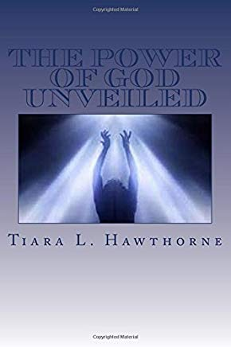
HE SAID UNTO THEM, HAVE YE RECEIVED THE HOLY GHOST SINCE YE BELIEVED? AND THEY SAID UNTO HIM, WE HAVE NOT SO MUCH AS HEARD WHETHER THERE BE ANY HOLY GHOST.
-ACTS 19:2

